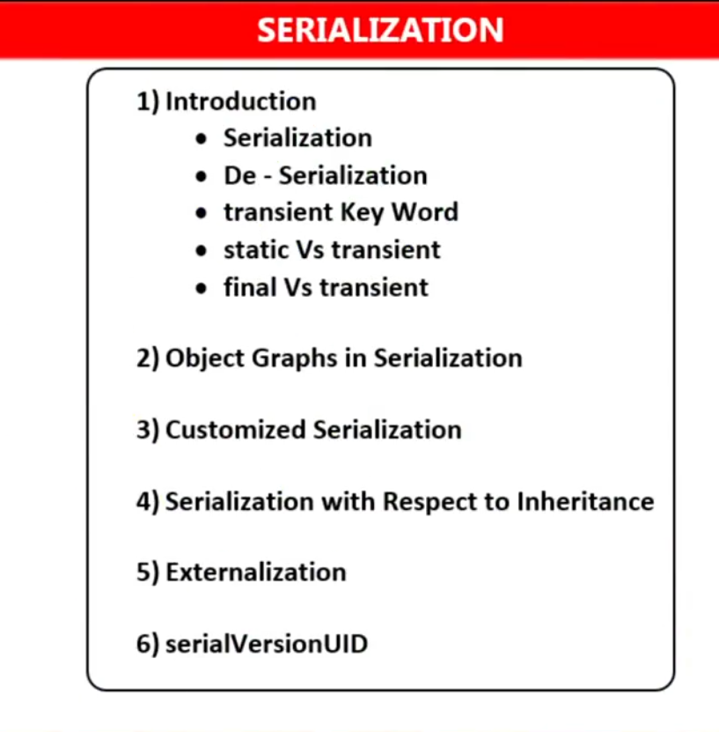

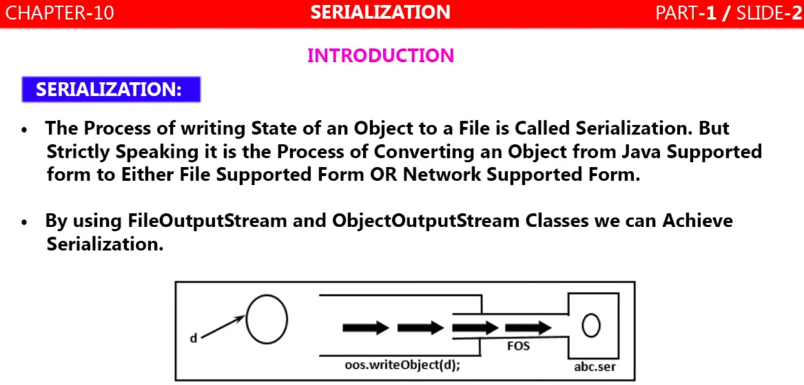

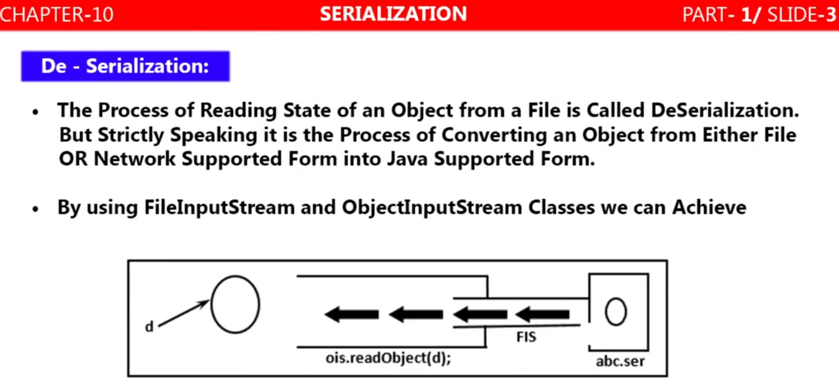

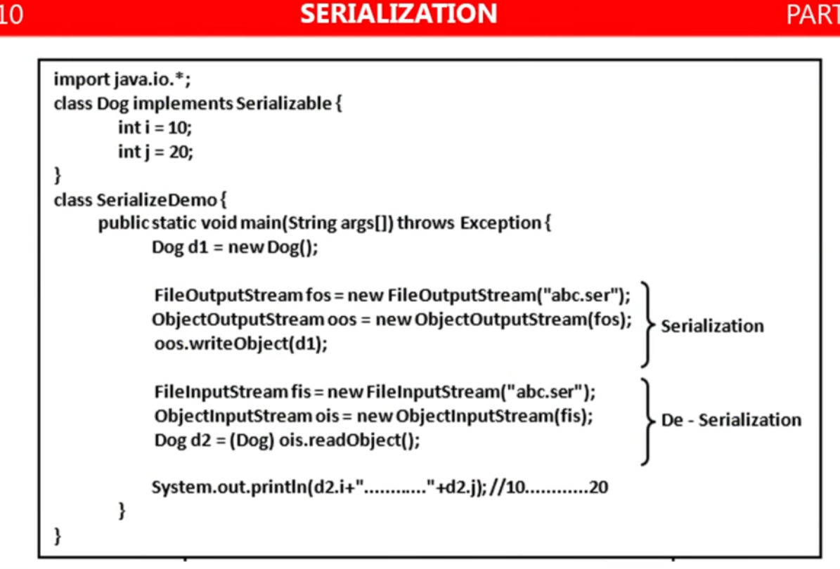

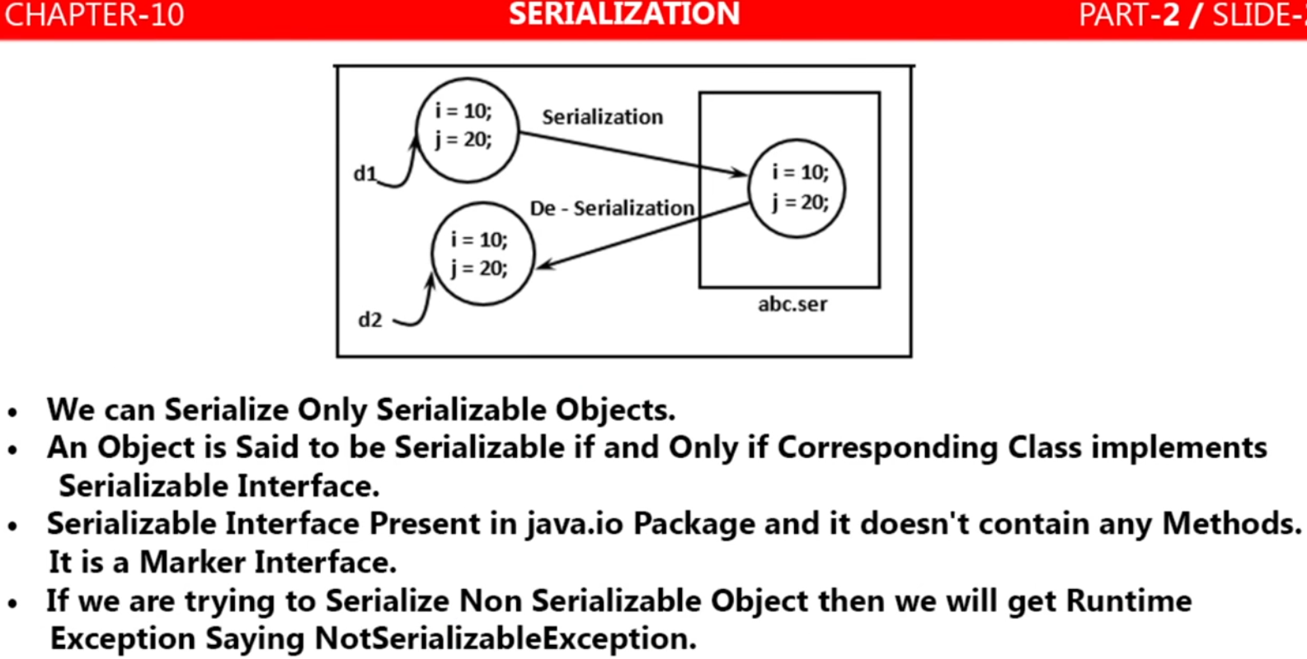

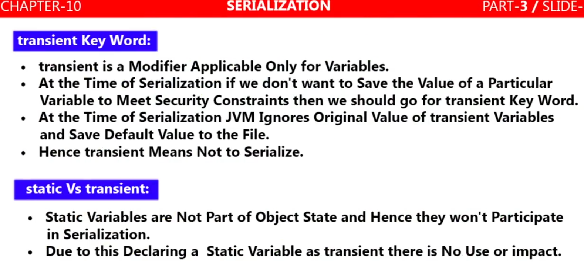

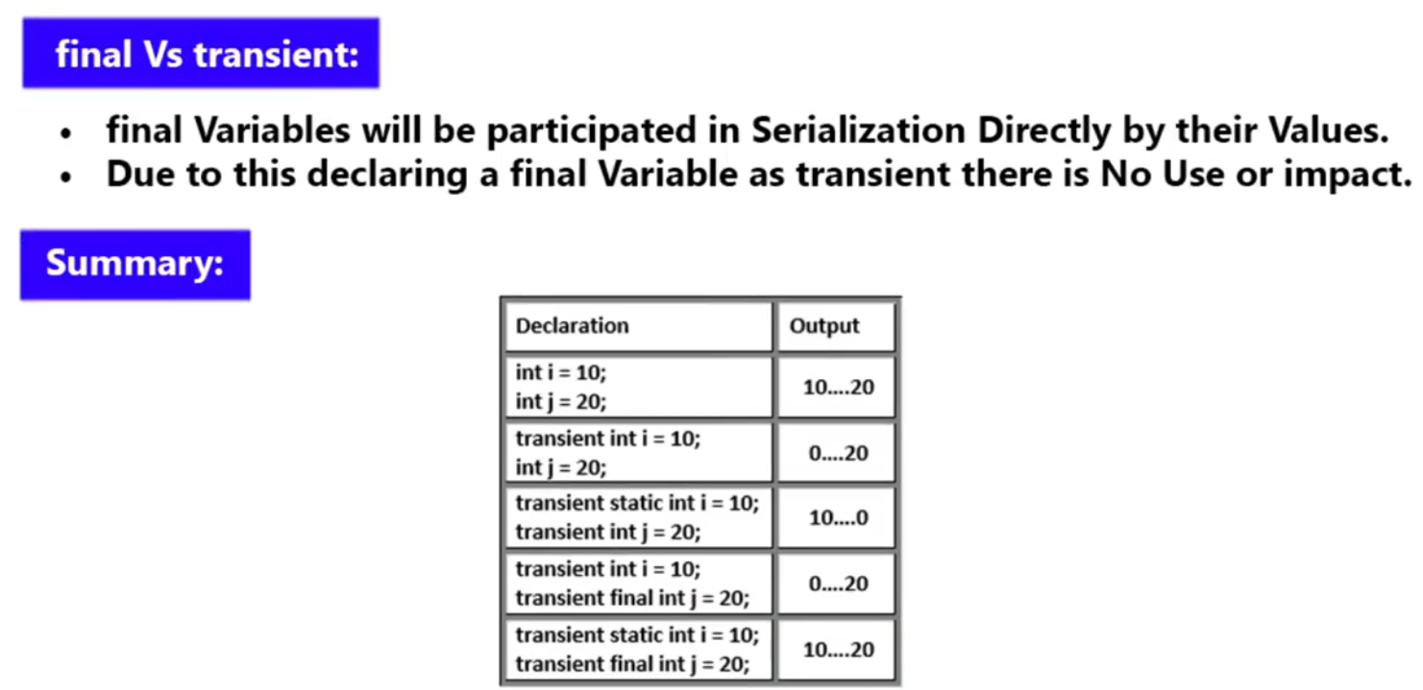

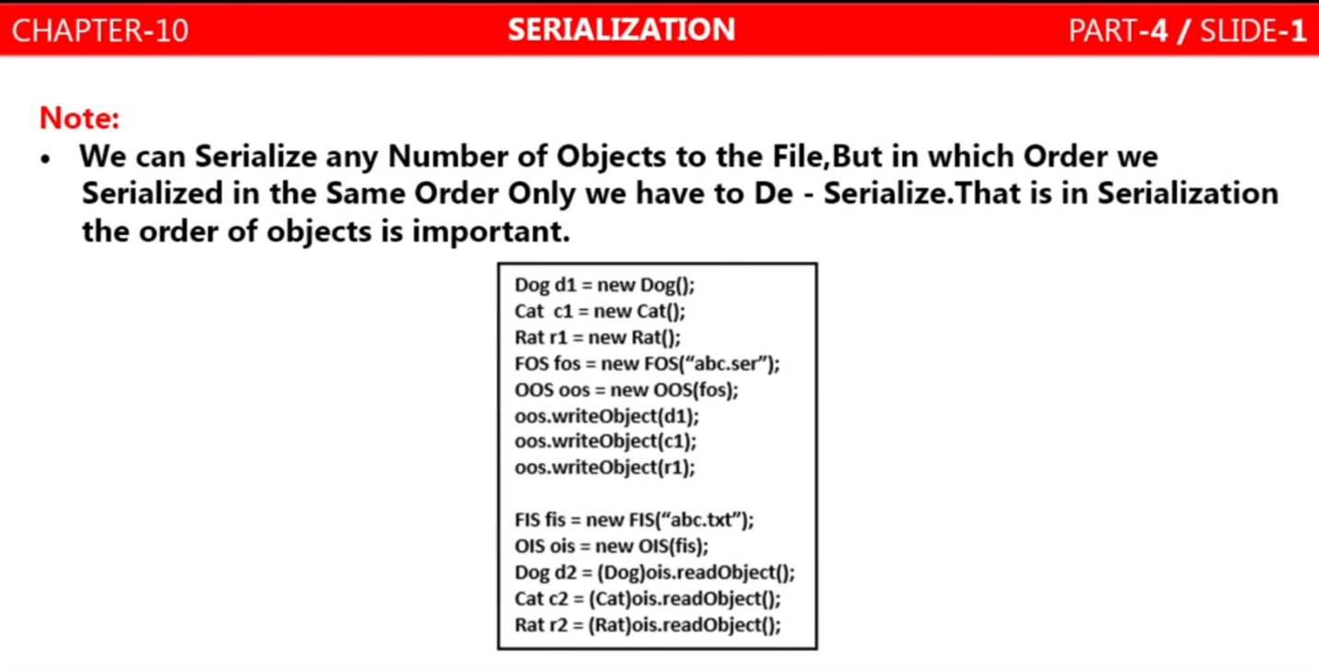

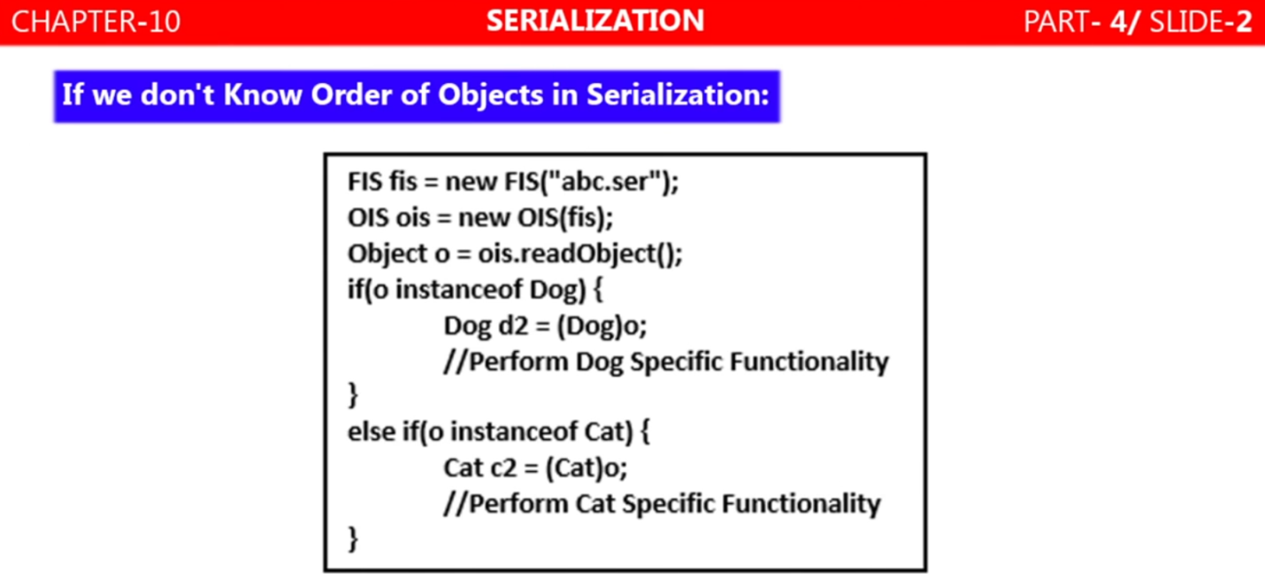

Here if we don’t know the order of serialized object then during de-serialization first we will read all the serialized object using Object class which is the parent of all the classes. Now it will have all the serialized object. Since according to OOPs concept Parent class reference can be used to hold child object but using that reference the child specific method can’t be called. So we will type cast the child class using parent class reference as we have done next

Next we will check if Object (o) is the instance of any serialized object (Dog, Cat, Rat) then we will type cast the (Dog, Cat, Rat) class using Object (o) and we will get child class (Dog, Cat, Rat) object.

Now using these class (Dog, Cat, Rat) objects we can perform specific functionality of class (Dog, Cat, Rat)

**Object Graphs in Seriliazation:**

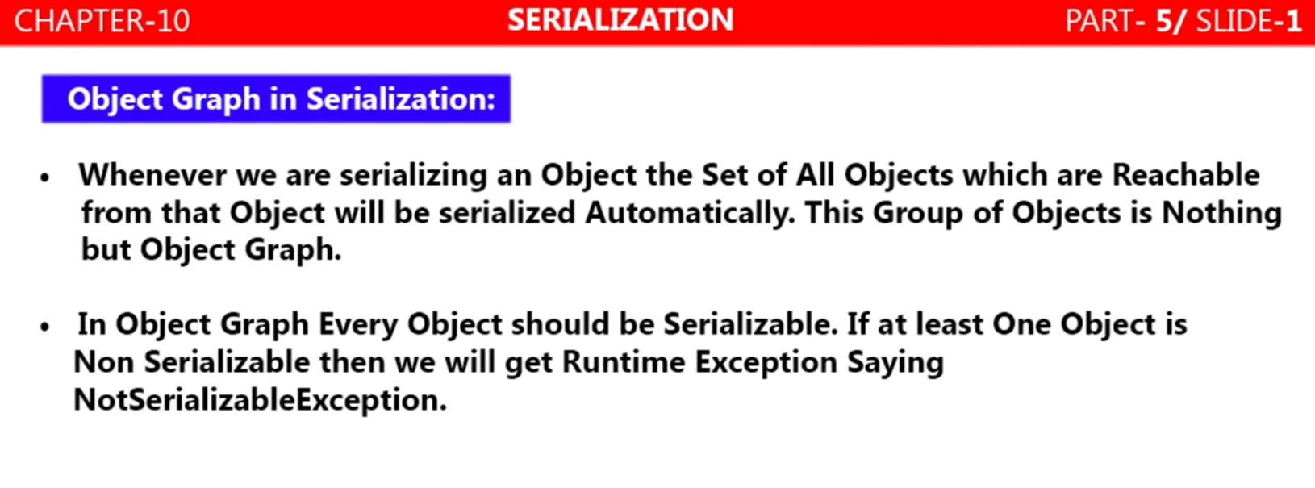

Here in the below example:

* We have created on Dog class and inside this class we have created an object of Cat class. Similarly
* We have created on Cat class and inside this class we have created an object of Rat class. Similarly
* We have created on Rat class and inside this class we have initiated one variable i=20
* Now in the main method when we create object of Dog class then automatically it will create object of Cat class and in-turn object of Rat class is also gets created as Rat object is created inside Cat class.
* Finally i=20 will initialized inside the Rat class.
* Hence we can say that all the object are reachable from one-another, this is nothing but object graph.
* In other word when we are serializing an object then the set of all object which are reachable from that object will be serialized automatically. This group of object is nothing but Object graph.
* Now if we serialize Dog object then automatically Cat and Rat Class object will be serialized
* Similarly during de-serialization Dog class object then other class like Cat and Rat class will be de-serialized automatically and as we can see in the above example that as soon as Dog class de-serialized we can access Cat and Rat class object also. [**System.out.println (d2.c.r.j)**]. It will print Rat class variable value.
* Since Dog class contains Cat class object and Cat class contain Rat Class object i.e. Rat class is reachable by Cat class, and Cat class is reachable by Dog class object. So if Dog class implements Serializable interface then other two class Cat and Rat must implements Serializable interface i.e. if any of two class (Cat and Rat) does not implements Serializable interface and Dog implements Serializable interface then will get runtime exception [NotSeriliazableException]

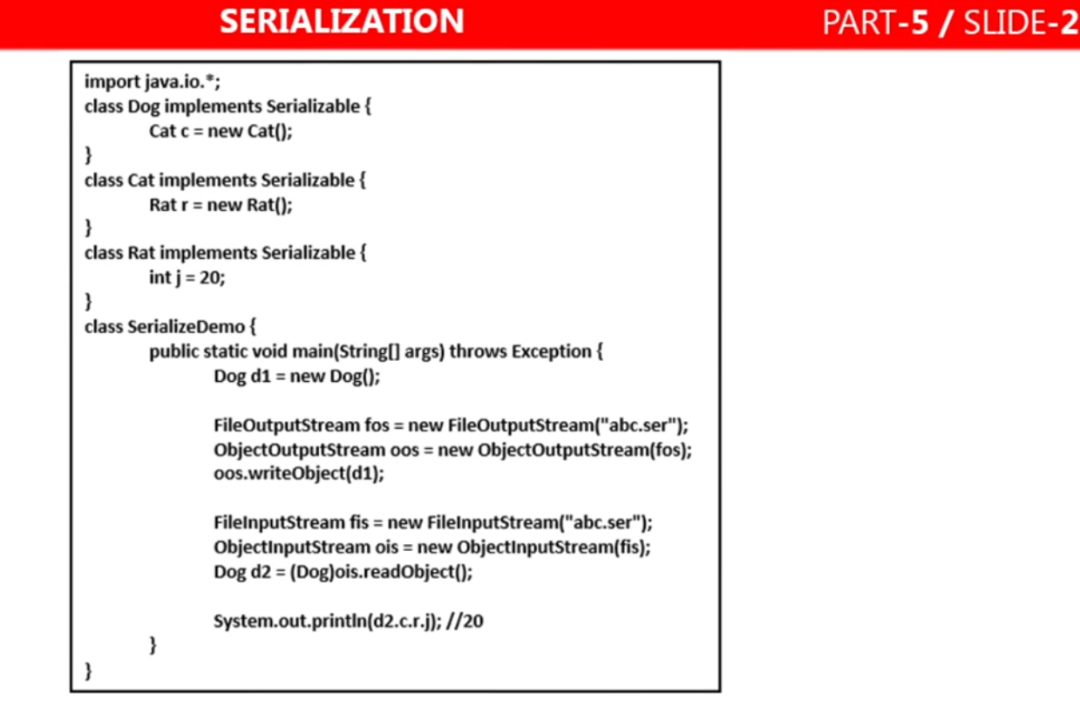

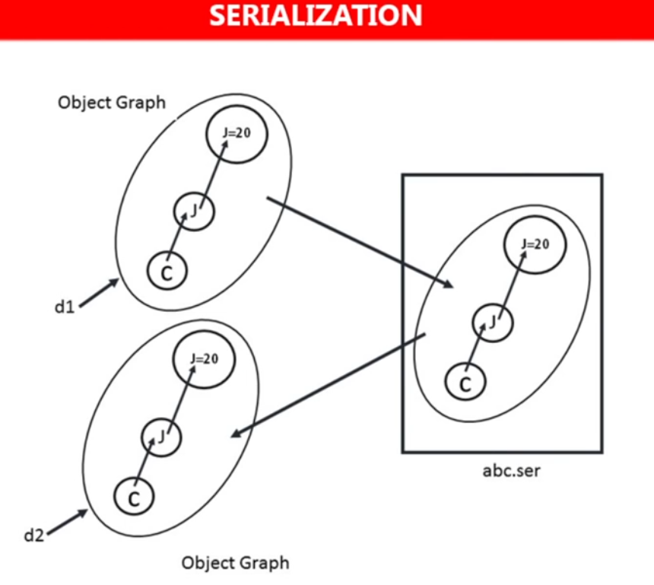

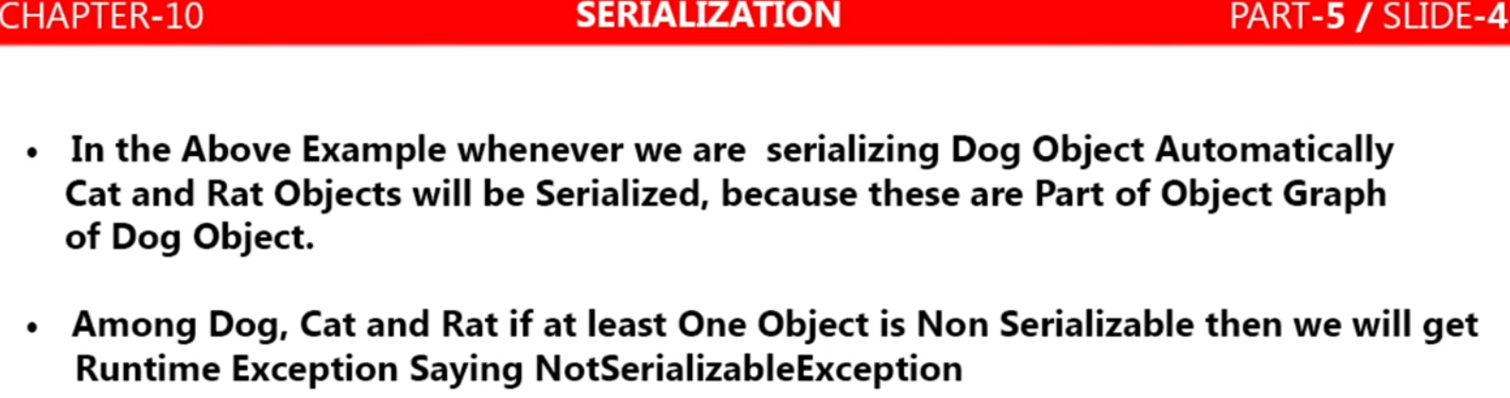

**Customized Serialization**

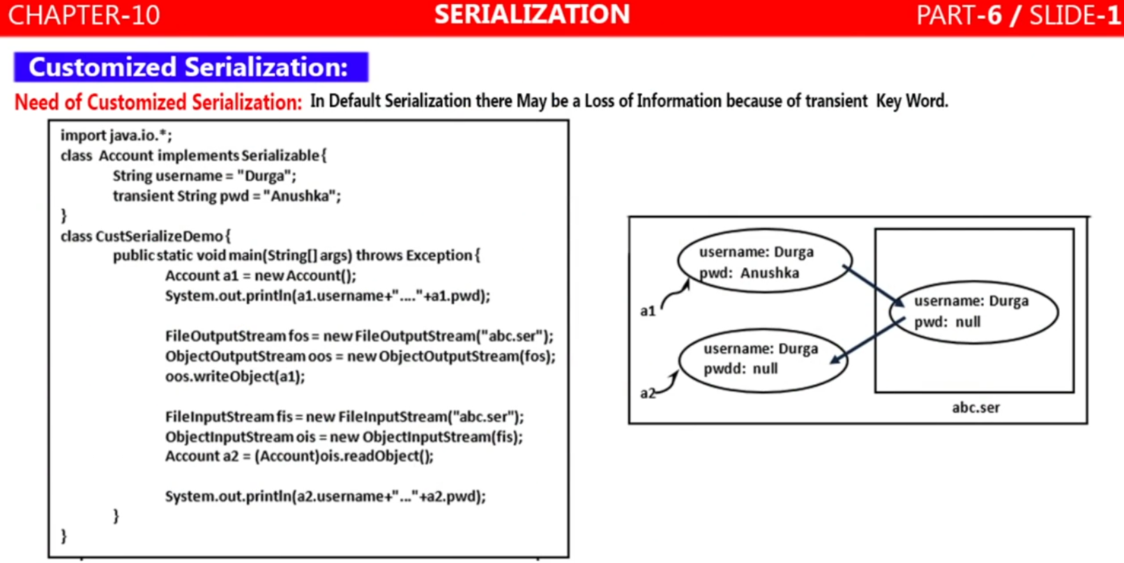

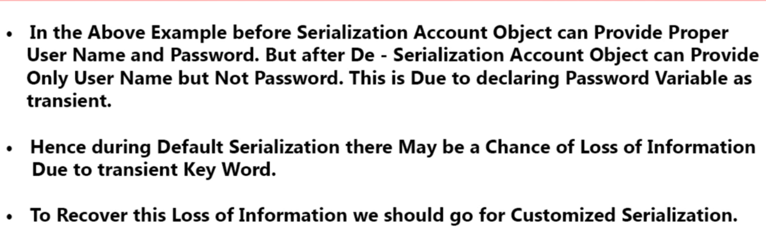

**Process or Implementation of Customized serialization:**

To do customized serialization we have to put some logic (like encryption) to hide important information from sender side before or during serialization and same. Similarly at the receiver side we have to put some logic (like decryption) to get the hide information during de-serialization. This extra logic is nothing but customized serialization.

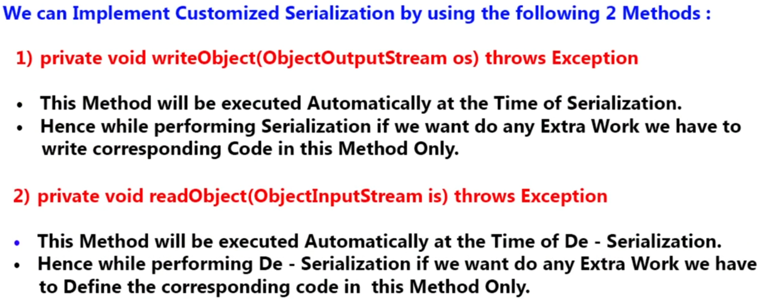

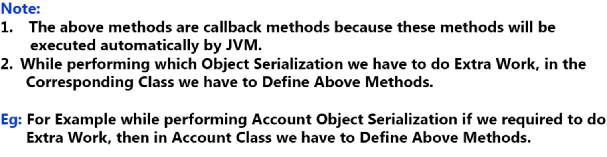

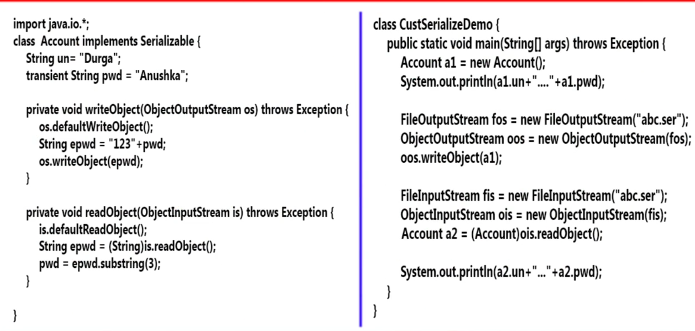

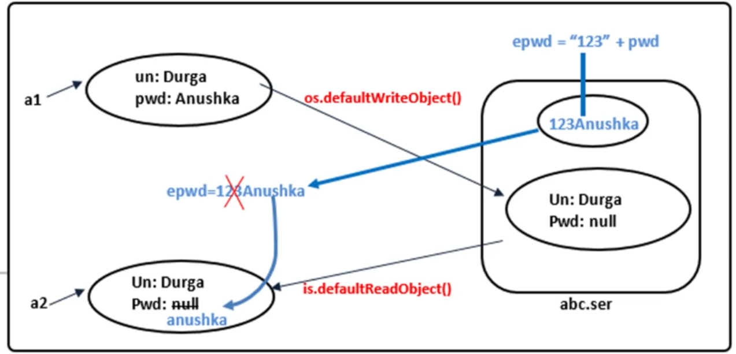

|  |
| --- |
| **package**com.customized.serilization;  **import** java.io.*;  **import** java.io.ObjectInputStream;  **import**java.io.ObjectOutputStream;  **import** java.io.Serializable;  **publicclass** Account **implements** Serializable {  **private static final long *serialVersionUID*** = 1L;  String username="Arun";  **transient** String pwd="Saraswati";  **private void** writeObject(ObjectOutputStream oos) **throws** IOException {  System.***out***.println("inside writeObject called by JVM");  oos.defaultWriteObject();// Meant for default serialization  String empwd= "123"+pwd;  oos.writeObject(empwd);  }  **Private void** readObject(ObjectInputStream ois) **throws** Exception{  System.***out***.println("inside readObject called by JVM");  ois.defaultReadObject();// Meant for default De-serialization  String empwd=(String)ois.readObject();  pwd=empwd.substring(3);  }  } |
| **package**com.customized.serilization;  **import** java.io.*;  **publicabstractclass**TestCustomizedSerilization {  **publicstaticvoid** main(String[] args) **throws** Exception {    Account a1 = **new** Account();  System.***out***.println("Before customization");  System.***out***.println(a1.username+"----"+a1.pwd);    System.***out***.println("Start Serilazation");  FileOutputStream fos = **new** FileOutputStream("abc.ser");  ObjectOutputStream oos= **new** ObjectOutputStream(fos);  oos.writeObject(a1);  System.***out***.println("End Serialiazation");    System.***out***.println("Start De-serialiazation");  FileInputStream fis = **new** FileInputStream("abc.ser");  ObjectInputStream ois = **new** ObjectInputStream(fis);  Account a2 = (Account)ois.readObject();  System.***out***.println("username"+a2.username+"-Password"+a2.pwd);  }  } |

**Note: 1-** During serialization the jvm will check that whether there is any code for customized serialization inside the class whose object has to be serialized. If JVM finds method [**privatevoidwriteObject (ObjectOutputStream oos)**] inside the class then it execute this method and does not go for default serialization. In this method can with our own logic for hiding the object like encryption.

**Note: 2-**During De-serialization the jvm will check that whether there is any code for customized de-serialization inside the class whose object has to be serialized. If JVM finds method [**privatevoid readObject (ObjectInputStream ois)**] inside the class then it execute this method and does not go for default de-serialization.In this method can with our own logic for getting the object like de-encryption.

|  |  |
| --- | --- |
| Before customization  Arun----Saraswati  Start Serilazation  inside writeObject called by JVM  End Serialiazation  Start De-serialiazation  inside readObject called by JVM  usernameArun-PasswordSaraswati | If we comment those two methods what we have written inside Account class then we will get fallowing answer.  Before customization  Arun----Saraswati  Start Serilazation  End Serialiazation  Start De-serialiazation  Username Arun-Password null |

As here we can see that after commenting methods it goes for default serialization and password is coming null as it is declared transient.

**Another example having more than one transient variable: (Pending)**

**Serialization with respect to Inheritance:**

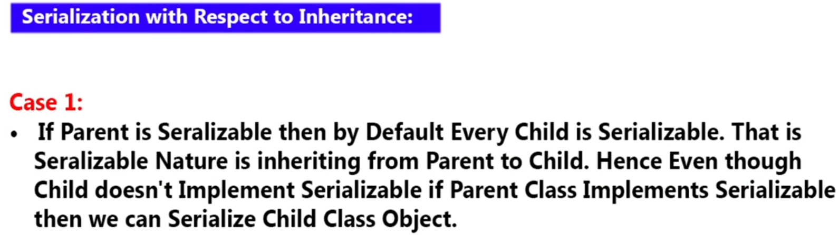

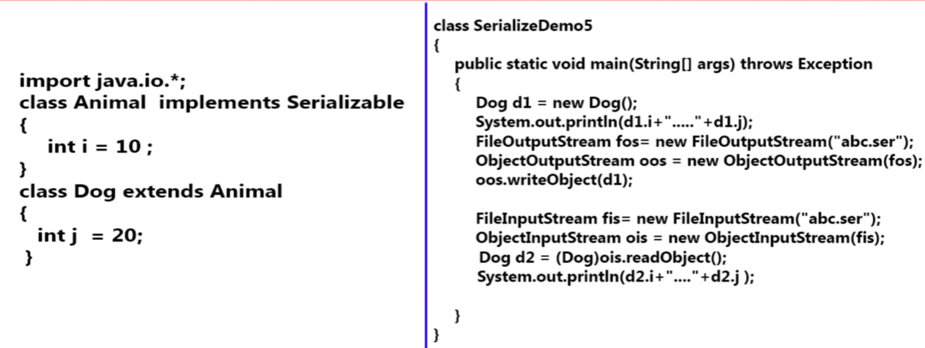

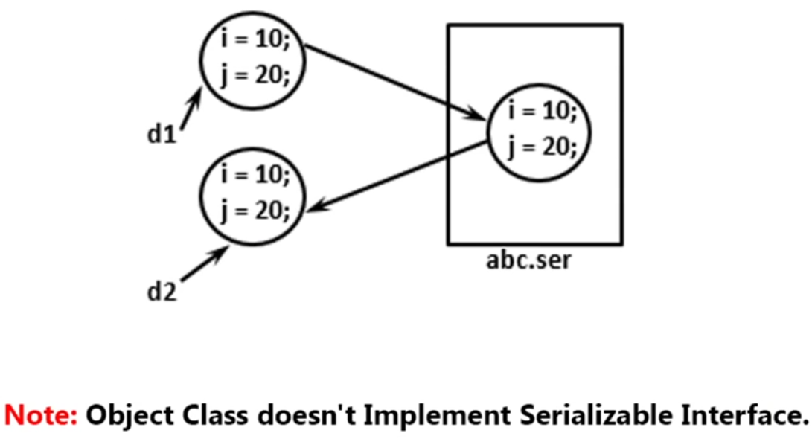

**Since every class is child class of Object so if Object class implements Serializable then every class will be Serializable automatically that is why object class does not implements Serializable**

**Hence serialization nature is inheriting from parent to child means every child will Serializable automatically if child class is Serializable**

**GenericServlet class implements Serializable hence all the servlet which extends GenericServlet is automatically becomes Serializable. HttpServlet class also implements Serializable interface as it extends abstract GenericServlet.**

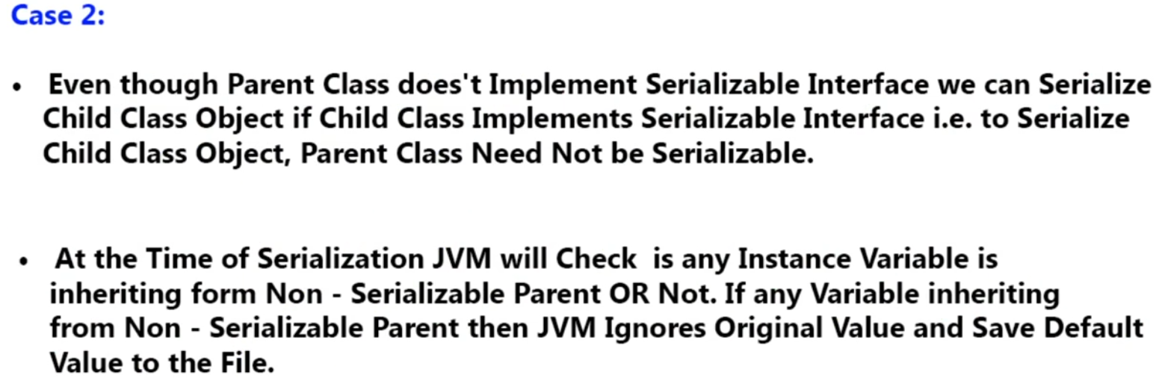

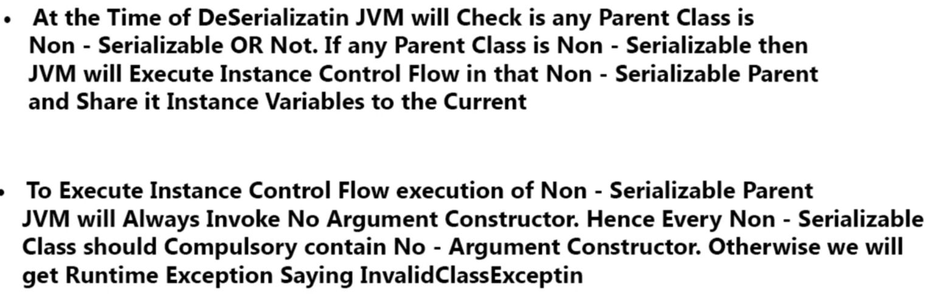

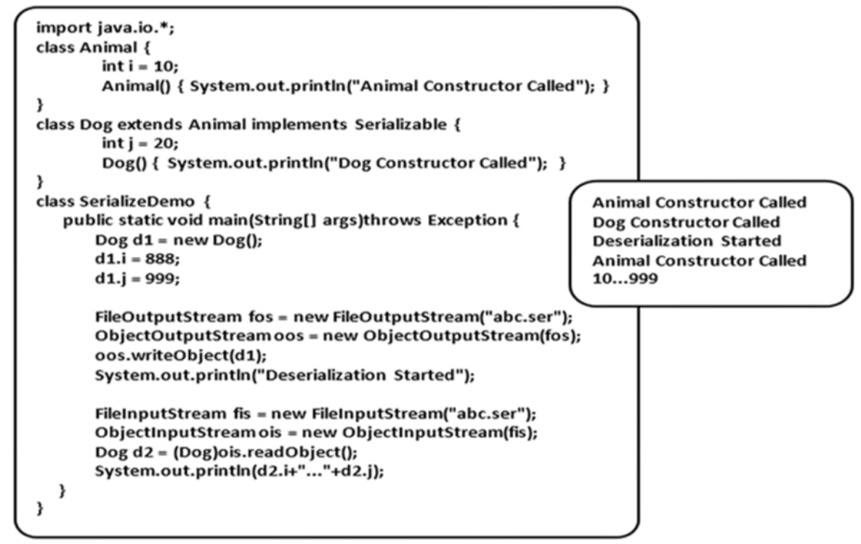

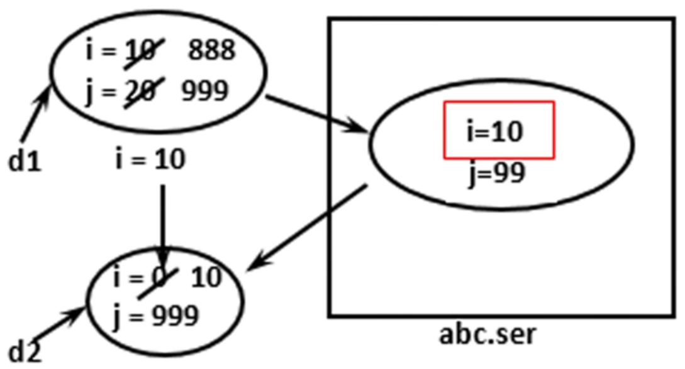

**Example Pending:**

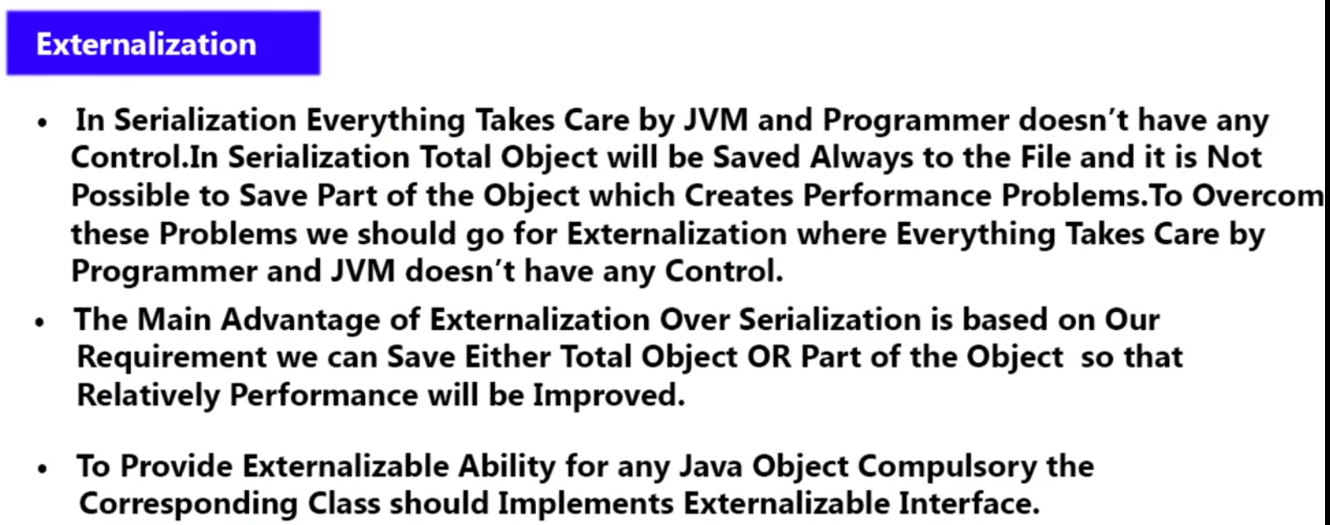

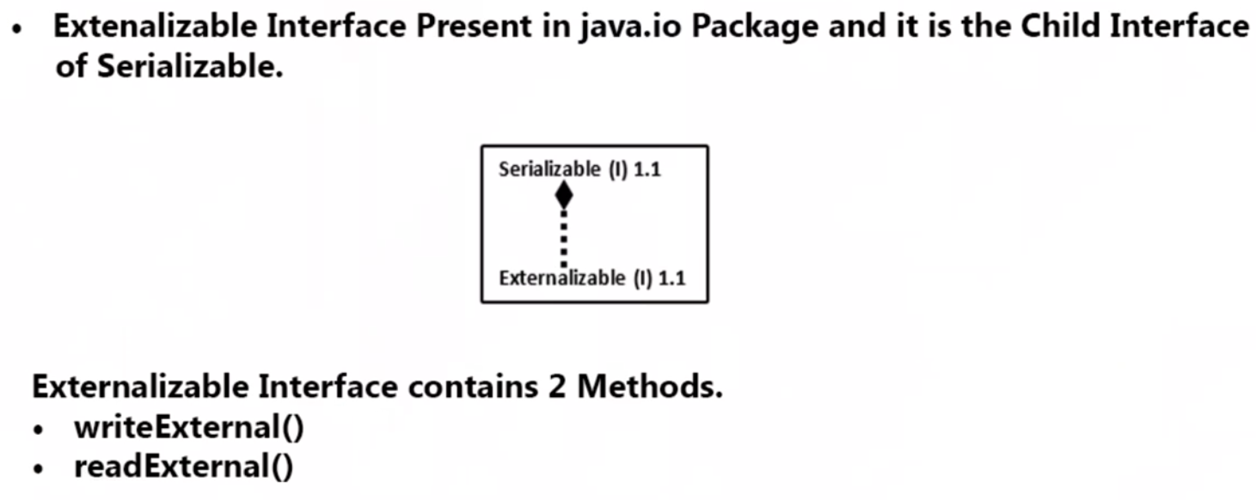

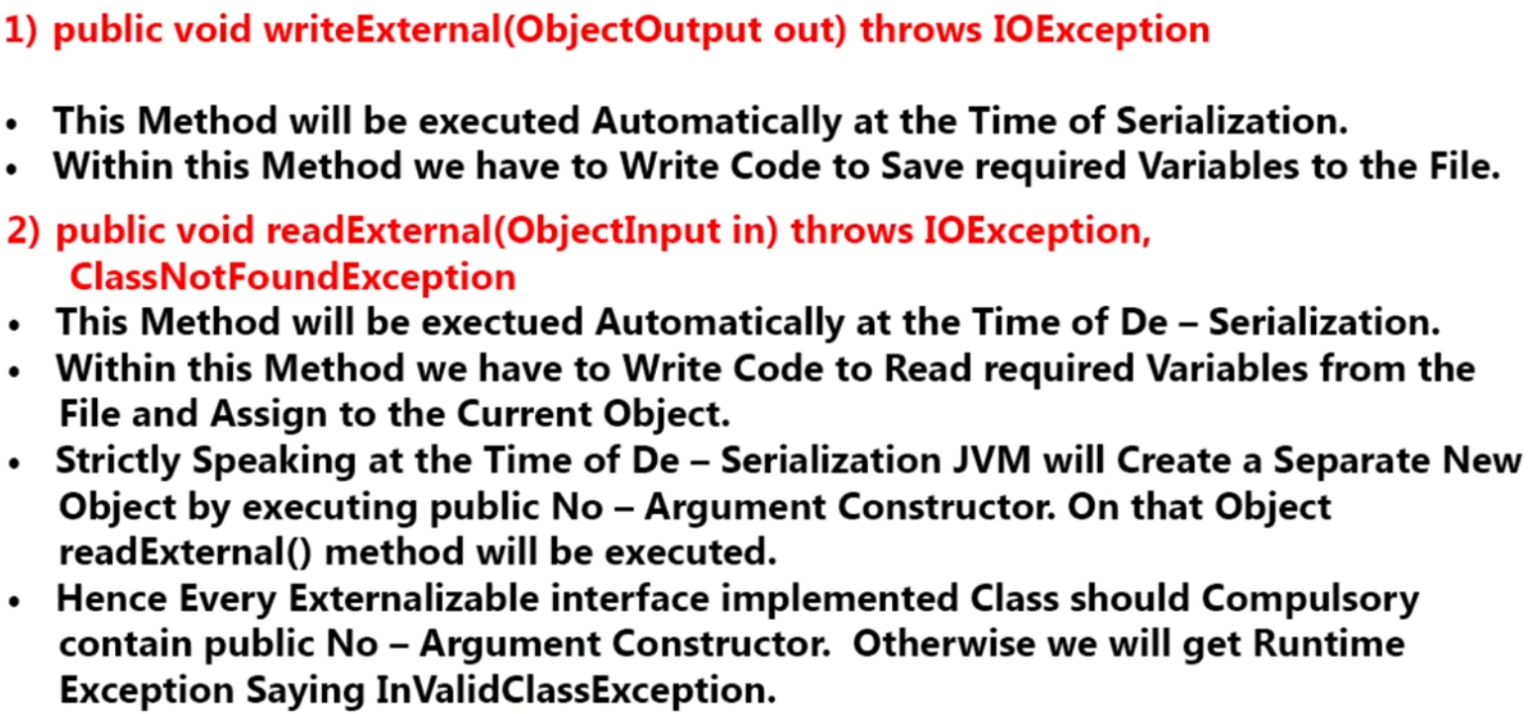

Let’s say we have one Account object and in that A/C object we have 1000 properties like name, account number etc. Now the advantage of the serialization is that we just need to write three line of code to serialize and again only three lines are required to de-serialize the account object. Hence everything is taking care by JVM. Programmer role is very less in serialization and de-serialization.

The disadvantage is that when we do object serialization then all 1000 property will be saved in file, but it is not possible to save part of properties of object in the file. Now let’s say out of 1000 properties we need only 3 to 4 properties then it is not possible to serialize only 3 to 4 property of the object. Hence to serialize and de-serialize 1000 object will create performance issue. Hence in case of Serialization programmer does not have any control.

In short we have two advantages in serialization

1. It is not possible to save part of object.
2. Programmer does not have any control. Everything is taken care by JVM only.
3. Performance will be decreased relatively as every property will take part in serialization and de-serialization.

To overcome above two problem we should go for Externalization concept.

The advantage of Externalization is.

1. It is possible to save part of object.
2. Programmer will have full control and JVM will not have any control.
3. Performance will be increase relatively because only required properties will take part in serialization and de-serialization.

Hence using Externalization based on our requirements we can save either total properties of object or part of the properties of the object. We can save even one variable out of 1000 variable in the file. Hence relatively performance of the system be improved automatically.

Hence we can say that when we have to serialize full object then we should go with Serialization and when a part of object has to be serialized then when we should go for Externalization.

As to provide serialization ability we have to implement Serialization Interface. In the same way to provide externalization ability we have to implement Externalization Interface.

Serialization is a marker interface whose total ability will be provided by JVM but in case of Externalization programmer is responsible to provide ability. Hence Externalization interface contain two method for providing ability. It is not a marker interface.

1. writeExternal()
2. readExternal()

Serialization and Externalization both concept came in java 1.1 but Serialization is more famous in compare to Externalization because in Serialization everything is taken care by JVM and while in case of Externalization programmer has to do everything. So because of this programmer’s laziness Externalization is not famous. Programmer thinks why I need to take unnecessary headache, let the JVM take all the headache.

Q: Now the question comes when writeExternal () and readExternal () method will executed?

|  |  |
| --- | --- |
| **writeExternal** | **readExternal** |
| 1. This method will be executed automatically at the time of serialization. | This method will be executed automatically at the time of de-serialization. |
| 1. Since in Externalization programmer is responsible to save required properties to the file, so programmer will write the code for serialization of those properties inside this method only. | Since in Externalization programmer is responsible to read required properties from the file and assigned to the current object, so programmer will write the code for de-serialization of those properties inside this method only. |
| writeExternal()  {   1. Sterilization for required properties 2. To save required properties to the file   } | readExternal()  {   1. De-Sterilization for required properties 2. To read required properties or variables from the file and assigned to the current object.   } |

**Note**: While using Exterminable then during serialization programmer will write all the code inside writeExternal () to save the required properties or variables in the file. But during de-serialization while reading required properties or variable (let’s say only one property accountNum from account object we need to read during de-serialization using externalization) from the file then at the receiver end its required a separate whole account object and then on this object readExternal() method will be executed. This separate whole object will be created by JVM by executing public no argument constructor. Hence while using Externalization compulsory should have public no argument constructor during de-serialization. If this constructor is not there then will get runtime exception saying Invalid Class Exception.

Since in case Serializable then programmer need not to declare any public no argument constructor because in serialization the whole object properties take part in serialization and de-serialization.

|  |
| --- |
| **package** com.nordea.externization.example;  **import** java.io.FileInputStream;  **import**java.io.FileNotFoundException;  **import** java.io.FileOutputStream;  **import** java.io.IOException;  **import** java.io.ObjectInputStream;  **import**java.io.ObjectOutputStream;  **publicclass**TestExternaization {  **publicstaticvoid** main(String[] args) **throws** IOException, ClassNotFoundException {  System.***out***.println("Start serialiazation using externalization..");  ExternalizeAccountObject t1= **new** ExternalizeAccountObject("Arun","1072052P",1000);  FileOutputStream fos = **new** FileOutputStream("ext.ser");  ObjectOutputStream oos = **new** ObjectOutputStream(fos);  oos.writeObject(t1);    System.***out***.println("Start de-serialiazation using externalization..");  FileInputStream fis = **new** FileInputStream("ext.ser");  ObjectInputStream ois = **new** ObjectInputStream(fis);  ExternalizeAccountObject t2= (ExternalizeAccountObject)ois.readObject();  System.***out***.println("Name-"+t2.name+"---Accoun Number"+t2.accountNum+"---Amount"+t2.amount);    }  } |
| **package** com.nordea.externization.example;  **import** java.io.Externalizable;  **import** java.io.IOException;  **import** java.io.ObjectInput;  **import** java.io.ObjectOutput;  **publicclass** ExternalizeAccountObject **implements** Externalizable {    **public** String name;  **public** String accountNum;  **publicint**amount;  // Creating public no args constructor  **public** ExternalizeAccountObject() {  System.***out***.println ("Inside no argument constructor....");  }  // Creating public with args constructor.  **public** ExternalizeAccountObject(String name , String accountNum , **int**amount) {  System.***out***.println ("Inside with argument constructor....");  **this**.name= name;  **this**.accountNum=accountNum;  **this**.amount=amount;  }  // Start serialization for required parameters name and amount  @Override  **publicvoid** writeExternal(ObjectOutput out) **throws** IOException {  System.***out***.println("Inside writeExternal called by JVM to serilize ");  out.writeObject(name);  out.writeInt(amount);  }  // Start de-serialization for name and amount  @Override  **publicvoid** readExternal(ObjectInput input) **throws** IOException, ClassNotFoundException {  System.***out***.println("Inside readExternal called by JVM to de-serilize ");  name = (String)input.readObject();  amount= input.readInt();  }  } |
| **Ouput :**  **Start serialization using externalization...**  **Inside with argument constructor....**  **Inside writeExternal called by JVM to serilize**  **Start de-serialization using externalization...**  **Inside no argument constructor....**  **Inside readExternal called by JVM to de-serilize**  **Name-Arun---Account Number- null---Amount-1000** |

Here Account number had not taken part in serialization hence while de-serialization happens its value came **null**. The output show the sequence of execution of program. Note during de-serialization no argument constructor is getting called without this no-argument constructor de-serialization is not possible. Here programmer role is important in serialization and de-serialization. Here in case of Externalization Transient key don’t play any role because programmer only is the responsible to serialize and de-serialize the properties.

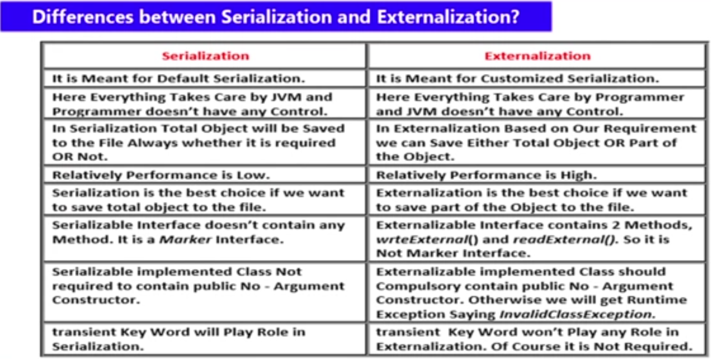

**SerialVersionUID**:

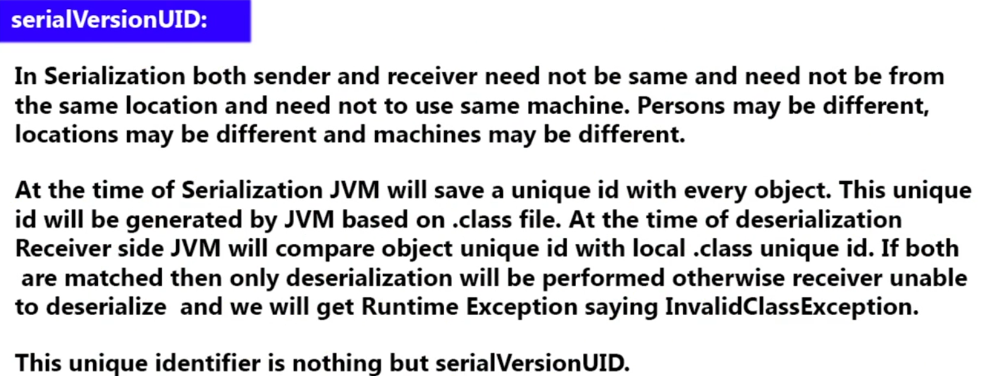

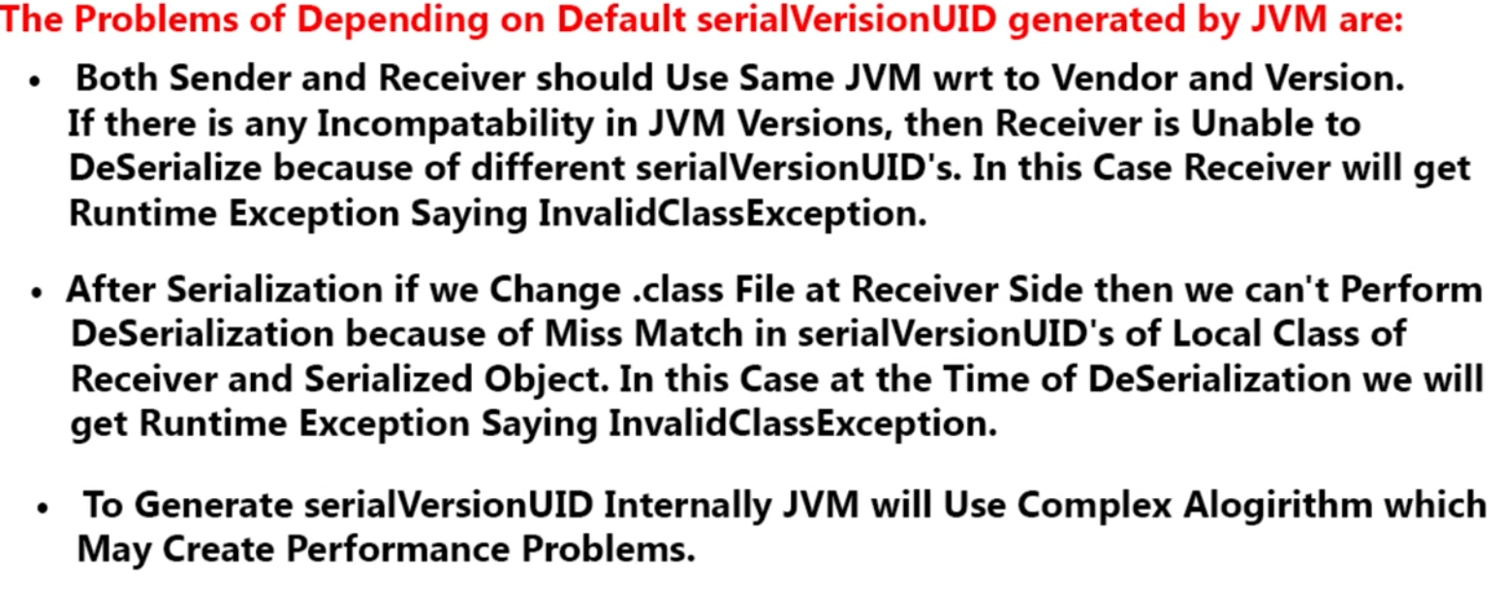

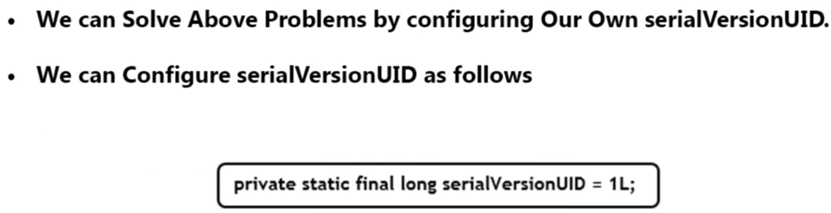

|  |  |
| --- | --- |
| **package** com.nordea.serialversion.uid;  **import** java.io.Serializable;  **public class** Dog **implements** Serializable {  **publicint**i =10;  **publicint**j =200;      } | **Package com.nordea.serialize.object;**  **import java.io.FileOutputStream;**  **import java.io.IOException;**  **import java.io.ObjectOutputStream;**  **import com.nordea.serialversion.uid.Dog;**  **public class Sender {**  **public static void main(String[] args) throws IOException {**  **Dog d1 = new Dog();**  **FileOutputStream fos = new FileOutputStream("dog.ser");**  **ObjectOutputStream oos = new ObjectOutputStream(fos);**  **oos.writeObject(d1);**  **}**  **}** |
| **package com.nordea.deserialize.object;**  **import java.io.FileInputStream;**  **import java.io.IOException;**  **import java.io.ObjectInputStream;**  **import com.nordea.serialversion.uid.Dog;**  **publicclass Reciever{**  **public static void main(String[] args) throws IOException, ClassNotFoundException {**  **FileInputStream fis = new FileInputStream("dog.ser");**  **ObjectInputStream ois = new ObjectInputStream(fis);**  **Dog d2= (Dog)ois.readObject();**  **System.*out*.println(d2.i);**  **System.*out*.println(d2.j);**  **}**  **}** | 1. Dog.java file has to compile first 2. **Then** Sender.java file has to compile. 3. **Then** Reciever.java file has to compile and run.   **Otherwise output will be default (o and 0) we will get.**  **Note: Since here we are not using SerialVersionUID, so let’s say we have made any change in dog.java file and compile but sender file does not execute their code, hence now whenever receiver try to execute their code he will get runtime exception**  Exception in thread "main" java.io.InvalidClassException: com.nordea.serialversion.uid.Dog; local class incompatible: stream classdesc serialVersionUID = 1, local class serialVersionUID = -3163142978222765606  Above exception means both the .class file has different serialVersionUID hence during de-serialization we are getting exception |

Now if we add one more line in dog.java file private static final long serialVersionUID=1L; Then we won’t get any exception even if made programmer made any changes in dog.java.

|  |  |
| --- | --- |
| **package** com.nordea.serialversion.uid;  **import** java.io.Serializable;  **public class** Dog **implements** Serializable {  **private static final long *serialVersionUID*** =1L;  **public int** i =10;  **public int** j =200;  **public int** k=30;  **public int** k1=40;  } | Here we have made two changes in dog.java and compile this but sender does not compile his code means k=30 and k1=40 could not be take part in serialization even though whenever receiver will execute his code he won’t get any exception because now dog.java file has add serialVersionUID so even there is mismatch of .class file of Dog. Class file at sender and receiver side still we get proper result. |

Don’t allow the JVM to create serialVersionUID, it recommended to create our own serialVersionUID to avoid this type of exception.

**Cloning in java**

* The process of creating exactly duplicate object is nothing but cloning.
* The main purpose of cloning is to keep original objet safe and unmodified.
* To preserver the original state of an object we must go for cloning.
* When we required any comparison with original object then it is recommended to create one clone of original object and the start modification on cloned object and then you can compare.